Pineapple INC

System Design Document
Of
Mobile claim Handling system

13-October-2014
Version 1.0

Submitted by
Ashtami bhuleskar(837316)
bharath reddy(839085)
Deepak B H(843640)
Rohan Adhaulya(835535)
Roshan chincholkar(852871)
Rupesh raut(8528)
vaishnaovi venkataraman(835098)



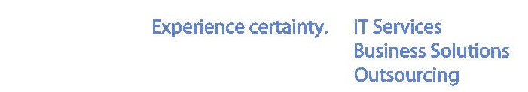

TCS Garima Park,

Garima Park, Infocity,
Gandhinagar – 382009
October 2014

DOCUMENT RELEASE NOTICE

Document Details:

Name | Version No. | Description
Mobile Claim Handling System | 1.0 | A manual process of claim validation of tens of thousand handsets everyday, globally, is tedious task. An electronic tool becomes viable solution for Pineapple INC.

Revision Details

Action taken  (Add / Del / Chg) | Preceding page no. | New page no. | Revision description

Review:
Reviewer | Date
Ms. Priya Varkey | 10/14/14
Ms. Priya | 10/14/14

Approval:
Approver | Date
Ms. Priya Varkey
Ms. Priya

Abbreviations

Abbreviation | Meaning
MCH | MOBILE CLAIM HANDLING
CA | CLAIM ADMINISTRATOR
RCM | REGIONAL CLAIM MANAGER
ASV | AUTHORIZED SERVICE VENDOR

Contents

1 Detailed Design 5
1.1 system maintenance 5
1.1.1 System Maintenance Functionality: 5
1.1.2 High level Design of System Maintenance 5
1.1.2.1 Class Diagrams 5
1.1.2.2 Sequence Diagrams 6
1.1.2.2.1 Claim Administrator Login 6
1.1.2.2.2 Create SWID 6
1.1.2.2.3 Delete SWID 7
1.1.2.2.4 Create RCM 7
1.1.2.2.5 Edit RCM 8
1.1.2.2.6 Search RCM 8
1.1.2.2.7 Delete RCM 9
1.1.2.2.8 Create Device and Warranty 9
1.1.2.2.9 Edit Device and Warranty 10
1.1.2.2.10 View Device by Device type/Warranty 10
1.1.2.2.11 Search by DeviceId/IMEINumber/DateofManufacture/DateofShipping 11
1.1.3 Data Model of System Maintenance 11
1.1.3.1 Group6_Login 12
1.1.3.2 Group6_CreateSWID 12
1.1.3.3 Group6_CreateRCM 12
1.1.3.4 Group6_Warranty 13
2 Glossary 14

Detailed Design

System Maintenance

System Maintenance Functionality:
- Claims Administration & SWID
  - Claims Administrator Login
  - Create SWID
  - Delete SWID
- RCM Maintenance
  - Create Regional Claims Manager
  - Edit Regional Claims Manager
  - View/Search Regional Claims Manager
  - Delete Regional Claims Manager
- Warranty Maintenance
  - Create new Device and Warranty
  - Edit device and Warranty
  - View device and warranty
  - Search device and warranty

High level Design of System Maintenance

Class Diagrams

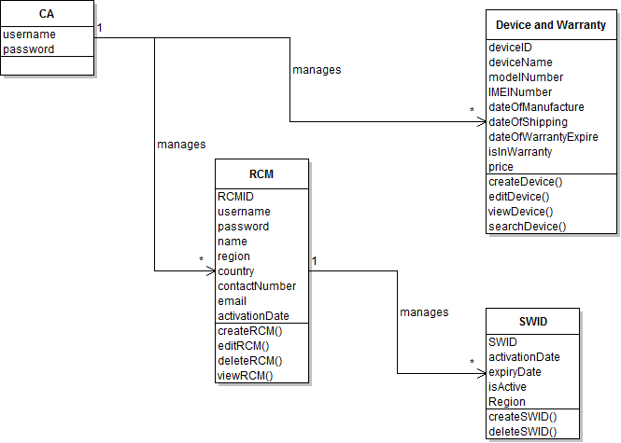

Sequence Diagrams
- Sequence diagrams for each SUC.
- Detailed Component

1.1.2.2.1 Claim Administrator Login

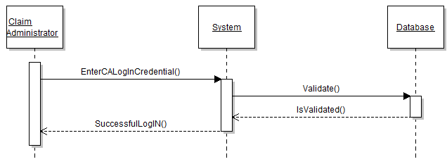

1.1.2.2.2 Create SWID
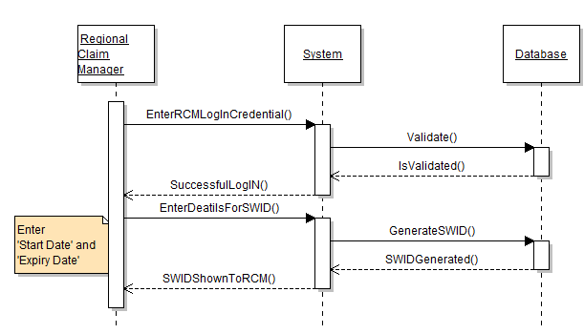

1.1.2.2.3 Delete SWID

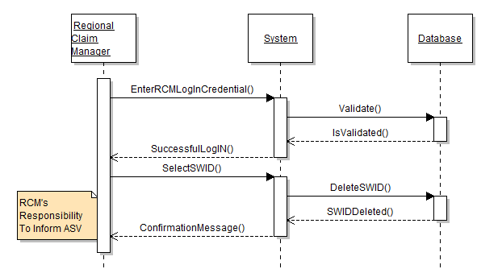

1.1.2.2.4 Create RCM
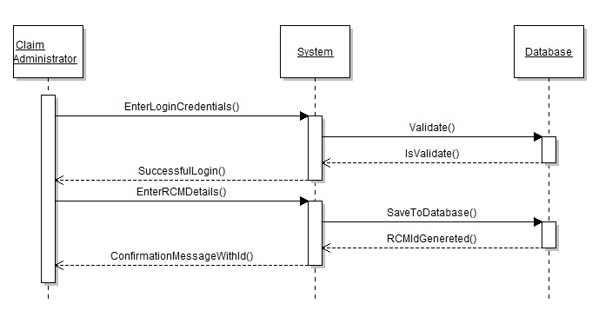

1.1.2.2.5 Edit RCM

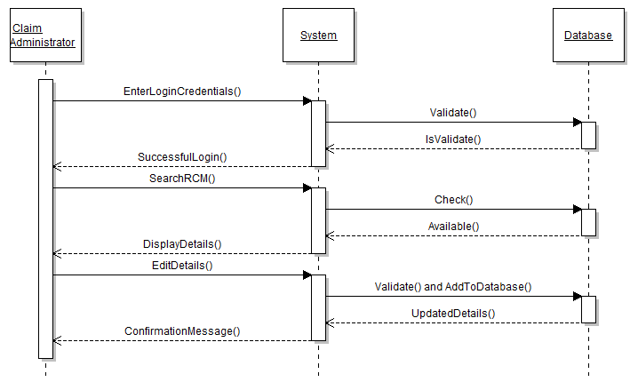

1.1.2.2.6 Search RCM

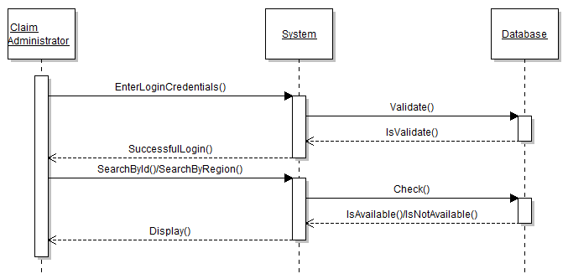

1.1.2.2.7 Delete RCM

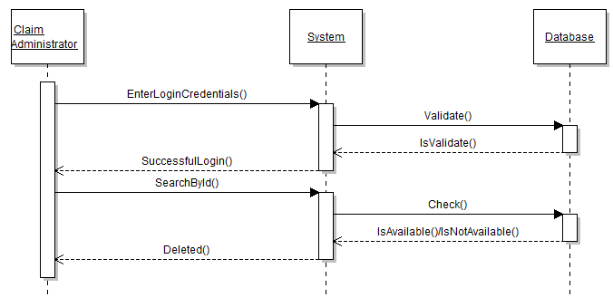

1.1.2.2.8 Create Device and Warranty.
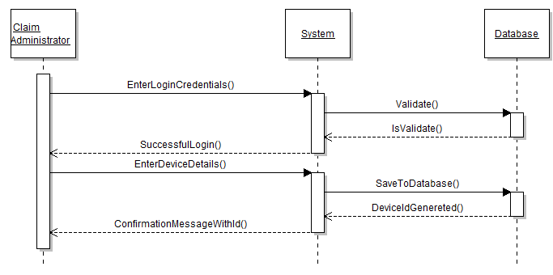

1.1.2.2.9 Edit Device and Warranty.

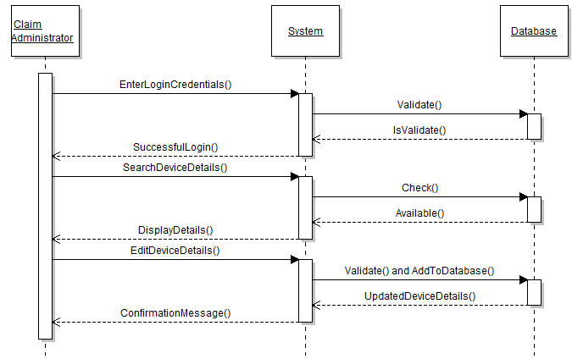

1.1.2.2.10 View Device by Device Type/Device Warranty

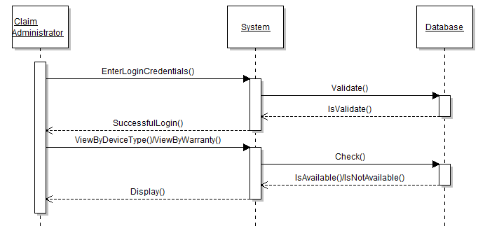

1.1.2.2.11 Search by DeviceId/IMEINumber/DateofManufacture/DateofShipping

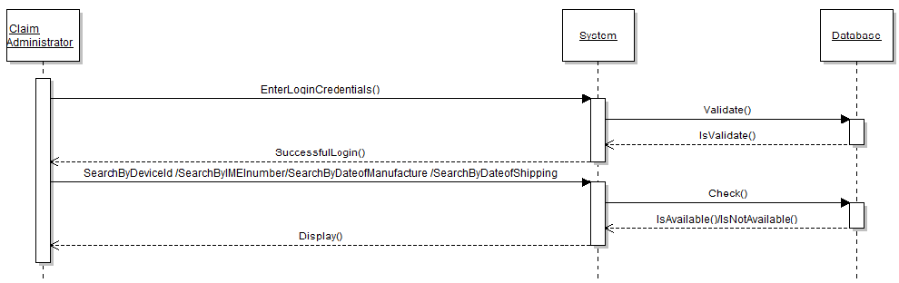

Data Model of System Maintenance

Group6_Login

Brief Description:
This table contains log in credentials details of both CA and RCM.
Attributes:

S.No | Attribute Name | Data type | Null | Remarks
 | Username | Varchar(30) | Not Null | Primary Key
 | Pwd | Varchar(30) | Not Null

Group6_CreateSWID
Brief Description:
This table contains database of SWID id generated.
Attributes:
S.No | Attribute Name | Data type | Null | Remarks
 | SWID | Varchar(12) | Not Null | Primary Key
 | ActivationDate | Date | Not Null
 | ExpiryDate | Date | Not Null
 | IsActive | Bit | Not Null
 | Region | Varchar(8) | Not Null

Group6_CreateRCM
Brief Description:
This table contains the details of Regional Claim Administrators.
Attributes:
S.No | Attribute Name | Data type | Null | Remarks
 | RCM_ID | Int | Not Null | Primary key
 | Username | Varchar(20) | Not Null | Unique
 | Password | Varchar(20) | Not Null
 | Name | Varchar(30) | Not Null
 | Region | Varchar(10) | Not Null
 | Country | Varchar(30) | Not Null
 | ContactAddress | Varchar(100) | Not Null
 | ContactNumber | BigInt | Not Null
 | Email | Varchar(30) | Not Null
 | DateOfJoining | Date | Not Null

Group6_Warranty
Brief Description:
This table contains details of new devices added in the system by Claim Administrator.
Attributes:

S.No | Attribute Name | Data type | Null | Remarks
 | DeviceId | Int | Not Null | Primary Key
 | DeviceName | Varchar(40) | Not Null
 | DeviceType | Varchar(20) | Not Null
 | IMEINumber | Varchar(16) | Not Null | Unique, depend upon Device Type if Mobile or Not
 | ModelNumber | Varchar(20) | Not Null
 | DateOfManufacture | Date | Not Null | Must be less than or equal to todays date
 | DateOfShipping | Date | Not Null | Must be greater than equal to Manufacture date and less than equal to todays date.
 | DatefOfExpiry | Date | Not Null | DateOfExpiry=DateOfShipping+1year
 | IsInWarranty | Bit | Not Null
 | Price | Money | Not Null

Glossary

Glossary Item | Glossary Item Description.
ASV | Vendors assigned by the company to take the claims from customer.
RCM | Managers who approve the status of the claims coming from ASV.
CA | Administrator who handles ASV & RCM functionalities.
SWID | It is a special warranty ID created by RCM for mobile devices for a particular region.

